

**Project 1**

**Restaurant Management System**

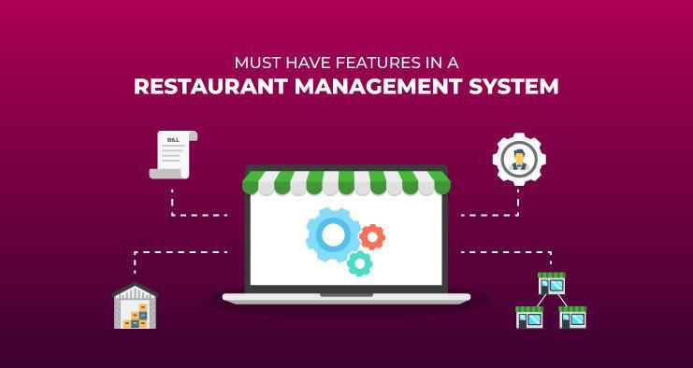

**A SIMPLILEARN PROJECT FOR BUSINESS ANALYST CAPSTONE COURSE**

**SUBMITTED BY: Shubham Saxena**

List of Project Tasks

**Project Task: Week 1**

* Identifying Stakeholders – Create a list of Stakeholders (as taught in Business Analysis Planning and Monitoring Knowledge Area)
* Create As-Is and Future Process map (using flowcharts). You can use any of the popular tools in the market like Microsoft Visio, Lucidchart, Creately, Pidoco, or Balsamiq
* As a Business Analyst working on this project, find out the scope of the Restaurant Management Software. Write down the main features that need to be developed.
* Write the in-scope and out-of-scope items for this software.
* Write out the business requirements, both functional and nonfunctional requirements.
* Draw wireframes or mock screens for two of the features namely *menu creation* and *table reservation*. Use the technique prototyping or wireframing that is taught in the training. You can use any of the wireframing tools like Microsoft PowerPoint, Microsoft Word, Balsamiq, Sketch, Adobe XD, Adobe ILLustrator, Figma, UXPin, InVision Studio, Invision Freehand, or Moqups.

**Project Task: Week 2**

* Make a product backlog of user stories for the given case study. User Stories should be in the format of As a <type of user>, I want <goal> so that <reason>
* For each story, write the acceptance criteria.
* Create a dashboard for senior management to view sales of restaurants for the last six months. Make assumptions as appropriate and create the dashboard using your own mock data.
* Create a dashboard to show which zone (Zone 1, 2, 3, or 4) has highest sales. Make assumptions as appropriate and create the dashboard using your own mock data.

Question 1:

* Create a bar graph for San Jose, Madison, and New York showing the sales. Label the chart drawn correctly so that senior management gets a clear report of sales.
* Arrange the data above in excel in an ascending and descending order for each city.

Question 2:

* In the above chart for restaurant ID 1200789, find the sales for the month of June
* In the above chart for restaurant ID 1200739, find the sales for the month of April
* In the above chart for restaurant ID 1200352, find the sales for the month of January

**Overview and Summary :**

A US celebrity chef James Oliver has his own chain of restaurants,

The Grill House, across different cities in the USA. He wanted to put a new Restaurant Management System to track the day-to-day management of his restaurant.

Currently they have a paper-based system for the same and this has many issues. Currently the orders were taken by the waiters on paper and a paper-based bill was presented to the customers.

All the bills were entered into an excel sheet by the manager at EOD to know the total sales and item wise sales for the day. Then reports were generated on excel to know trends and details like daily, weekly, and monthly sales. Which dishes were popular and which weren’t doing so well?

Restaurants need a system that will allow them to easily update their menu. The clients currently do not have a system that recognizes the different types of users such as managers, waiters, etc. And they would like to be able to limit the access of some options of the system to certain users.

The client invited Business Analysts trained at SimpliLearn to capture the requirements for the creation of this software.

**BUSINESS ANALYSIS CORE CONCEPT MODEL (BACCM)**

The conceptual framework of business analysis has been captured as outlined in the BABOK guide.

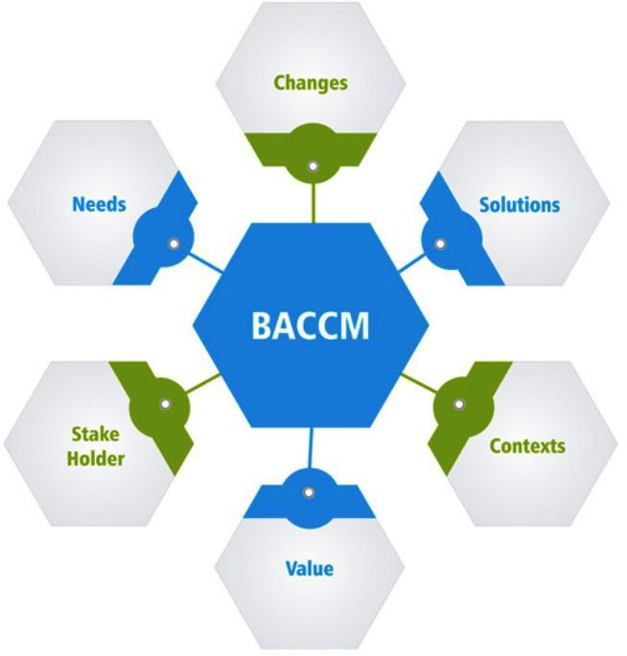

*Business Analysis Core Concept Model as per BABOK*

**Project Task 1: Identifying stakeholders**

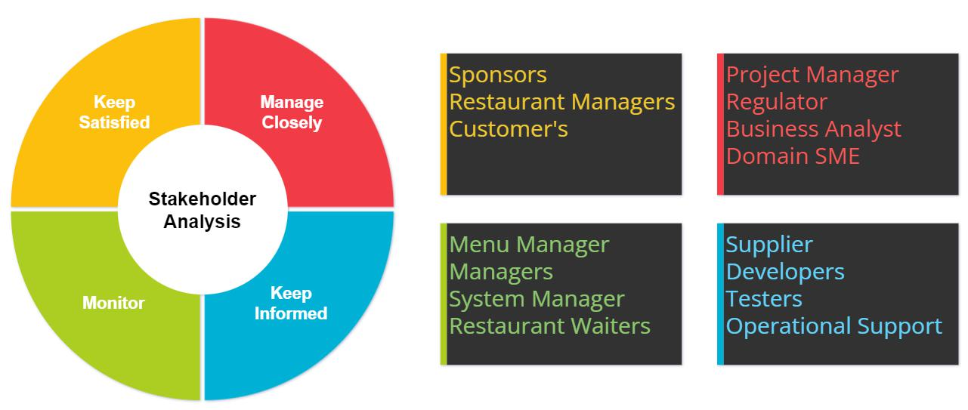

*STAKEHOLDER MATRIX SHOWING THE POWER/INTEREST OF STAKEHOLDERS*

Project Task 2: Create as-is and future process map (using flowcharts)

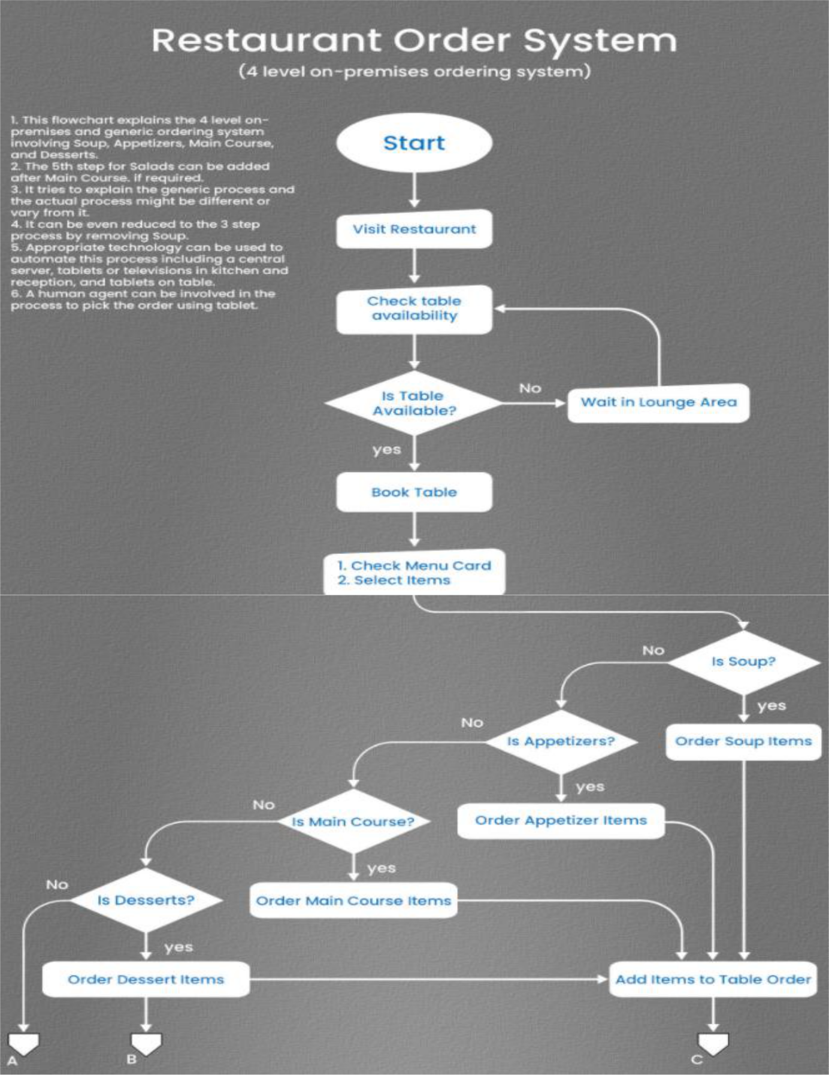

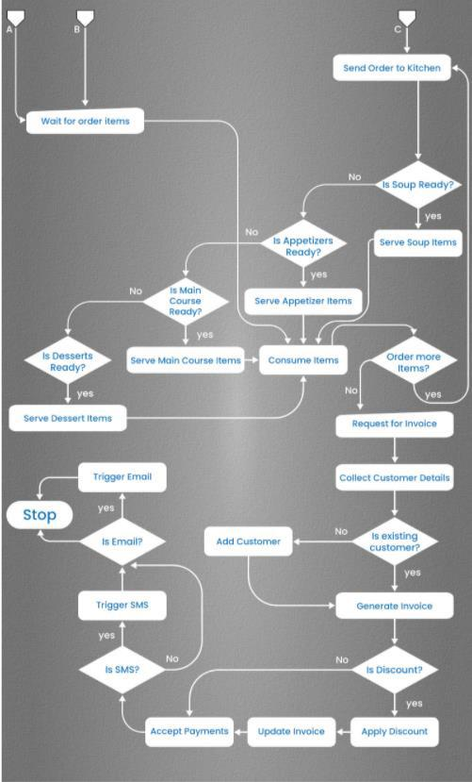

*As-is process map*

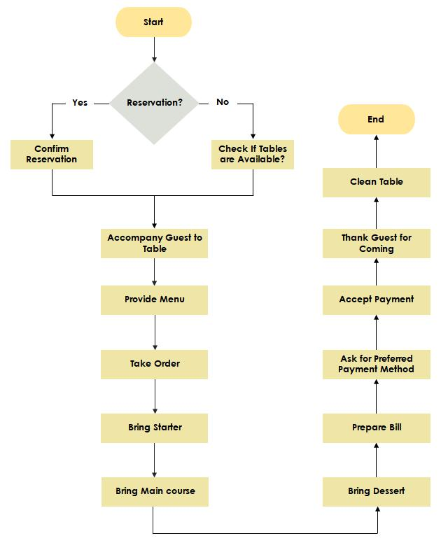

*Future process map*

**Project Task 3: Scope & Main Features to be developed**

Below are the main features & scope of the system which needs to be developed:

* A user-friendly web page for the Restaurant Management Software.
* Waiters and managers should be able to search items in the menu using the search facility.
* Managers, waiters & etc. registration and login on the system.
* After successful login, customers should be able to see the updated food menu with all the dishes and tables available.
* Access to the menu manager to create and edit the menu and table reservation.
* Once the order is confirmed, customers cannot modify or cancel the order
* After completion of the order, the customers will be asked to fill the feedback form for their order.
* The system should be able to reserve tables.
* Login for waiters, managers, and James Oliver (CEO) and change password facility to be offered.
* Customers can pay by cash or card. There should be a payment gateway on the system.
* System should be able to generate the bill.
* Automated report on most popular dishes, number of customers using the system, monthly earning, order forecasting and sales to the management.

**Project Task 4: In-Scope and Out-of-Scope Requirement**

**IN-SCOPE REQUIREMENT FOR THE SOFTWARE**

The Restaurant Management Software is designed to manage all these food ordering operations.

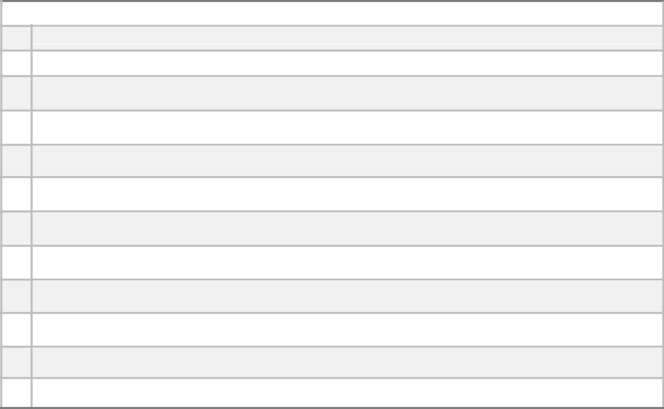

**In-Scope Requirements**

1. Registration / Login screen
2. Menu page
3. Meal ordering screen
4. Order confirmation screen
5. Payment summary
6. Order status page
7. Table confirmation
8. Forget Password
9. Generate Bills
10. Store Table Layout
11. Feedback submission
12. Sales report management

**OUT OF SCOPE REQUIREMENT FOR THE SOFTWARE**

The Restaurant Management Software will not include below mentioned areas in current scope.

|  |  |  |  |  |  |
| --- | --- | --- | --- | --- | --- |
|  |  |  | **Out of Scope Requirements** | | |
|  | **1** |  | Restaurant inventory management |  |  | |
|  |  |  |  |  |  | |
| **2** | | Food vendor management | | | |
|  | |  | | |  | |
|  | **3** |  | Restaurant staff payment management | |  | |
|  |  |  |  | |  | |
|  |  |  |  |  |  | |
| **4** | | Food supplies out of stock notification | | | |
|  | |  | | | |
|  | **5** | Chef and cook management | | | |
|  |  |  | | | |
|  |  |  |  |  |  | |
| **6** | | Use of the system by ex-employees or outsiders not allowed | | | |
|  | |  | | | |
|  | **7** | Chef ,manager and waiters person pay details | | | |
|  |  |  |  |  |  | |
|  |  |  |  |  |  | |

**Project Task 5: Functional and Nonfunctional Requirements for the software**



**Functional Requirements:**

The Restaurant Management Software have the following functional requirements :

* Online web or mobile application
* Signup / Login screen to verify employee’s details (Only Restaurant employees should be allowed to sign up with their employee ID)
* Menu for food selection
* Table reservation and confirmation
* Food order and payment summary
* Order tracking feature
* Feedback submission
* Reports formation



**Non-functional Requirements:**

Restaurant Management Software have the following non - functional requirements :

* Usability : User friendly system and self-explanatory screens
* Performance : System should be light and render fast
* Platform : Java platform as it required very little maintenance to be done on the code

**Project Task 6: Draw wireframes or mock screens**

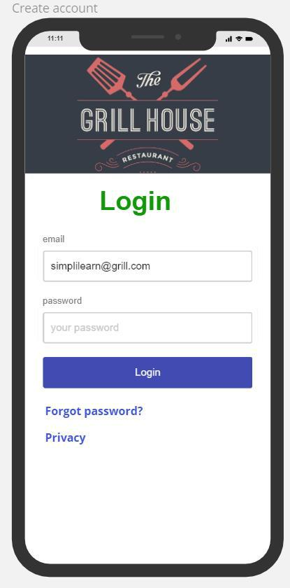

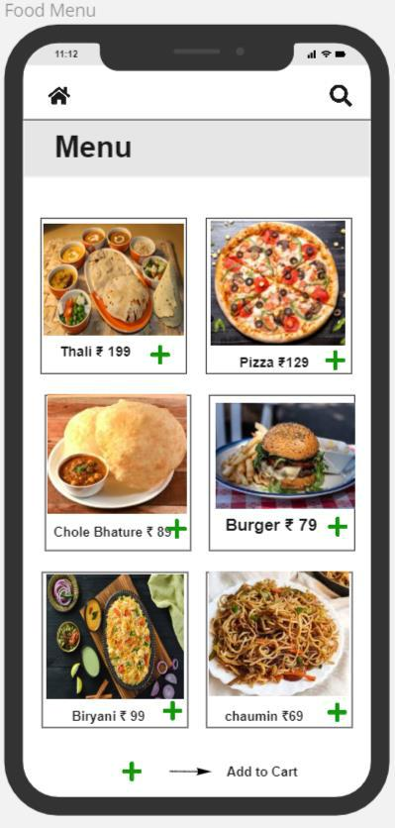

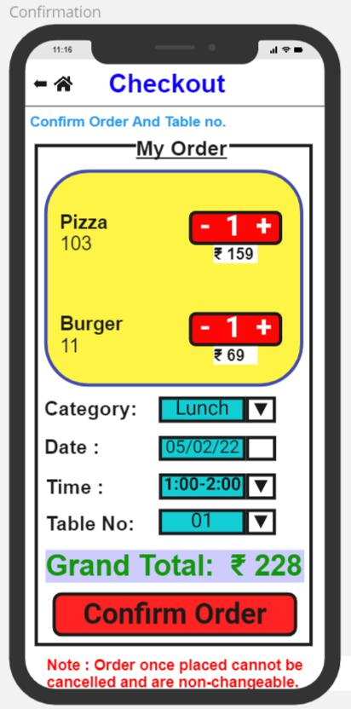

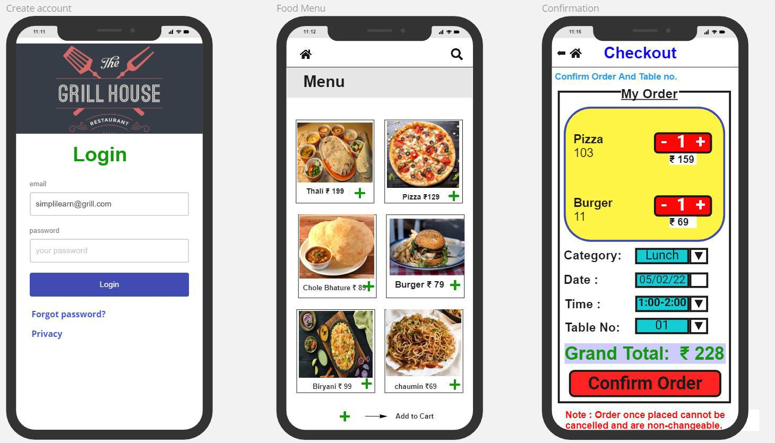



**PROJECT CREATION**

Restaurant Management System

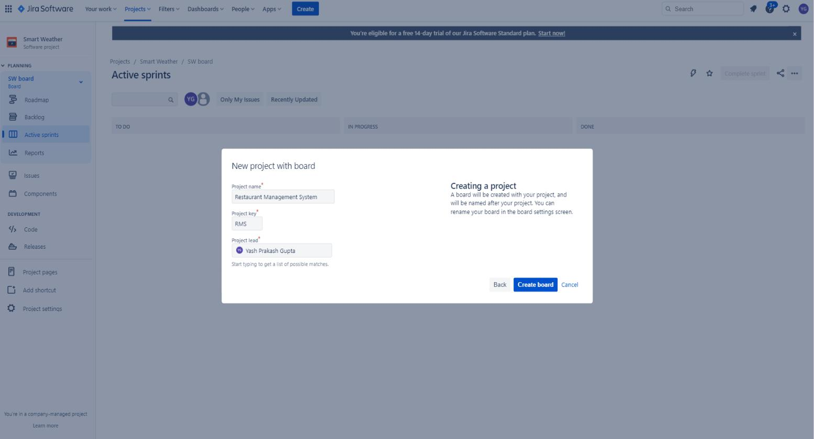

**Creating issues (Story)**

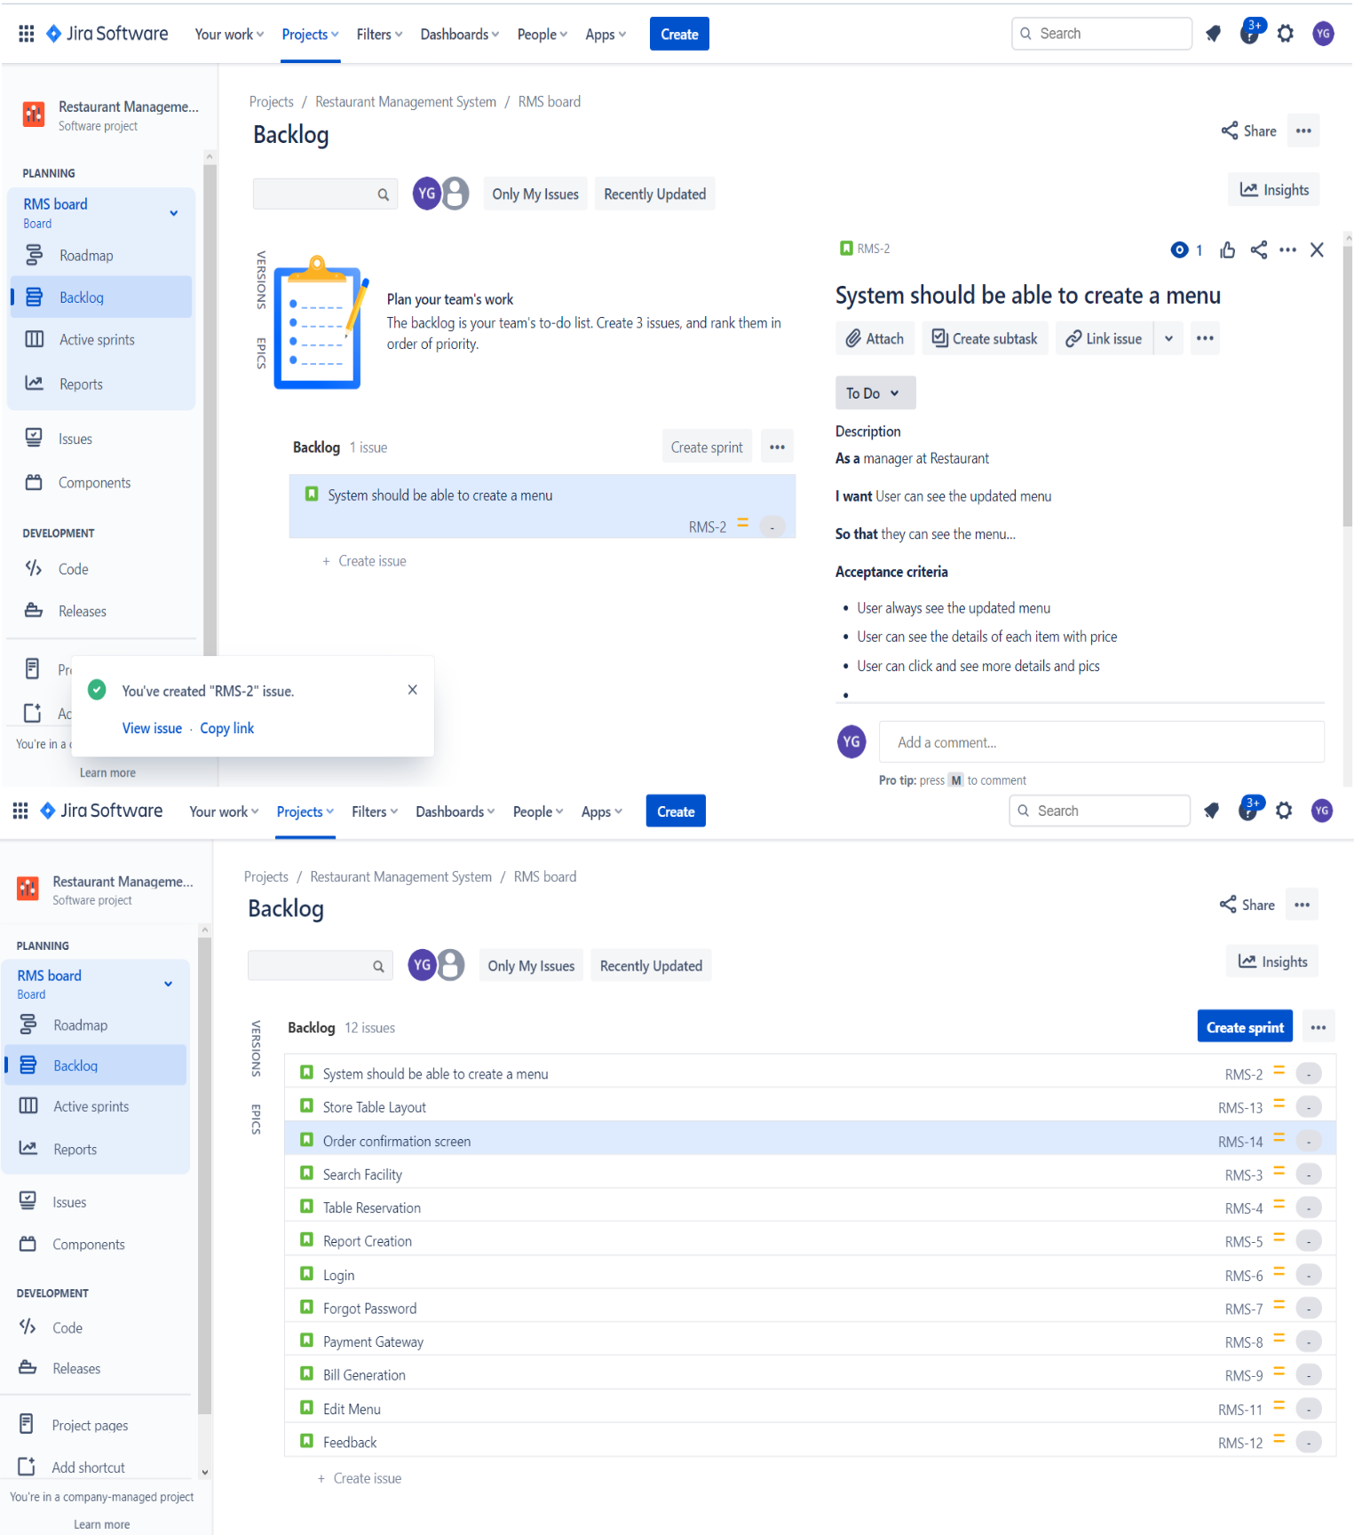

**Added Backlog,Story Points,Priority,User Story:**

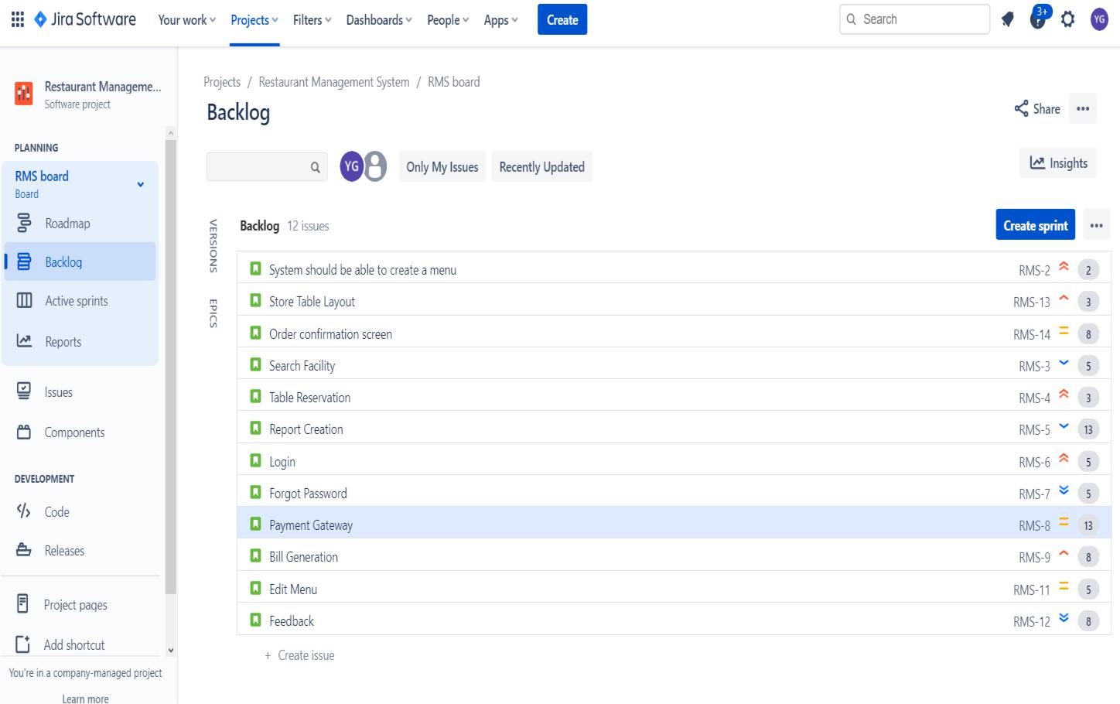

**Epic Created:**

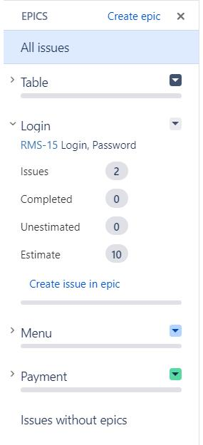

**Epic Added:**

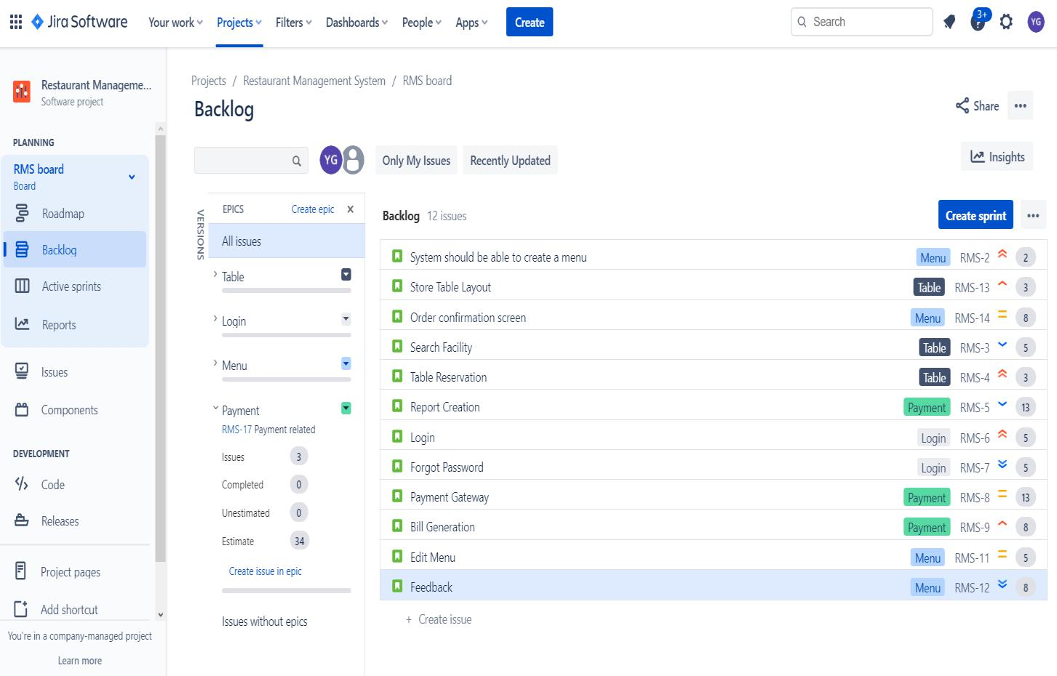

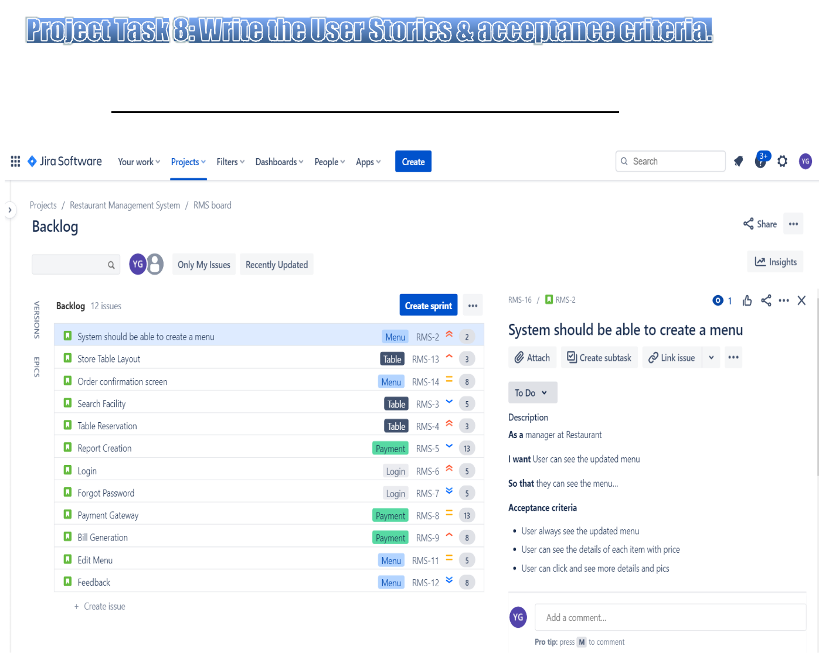

***Added Description and Acceptance Criteria:***

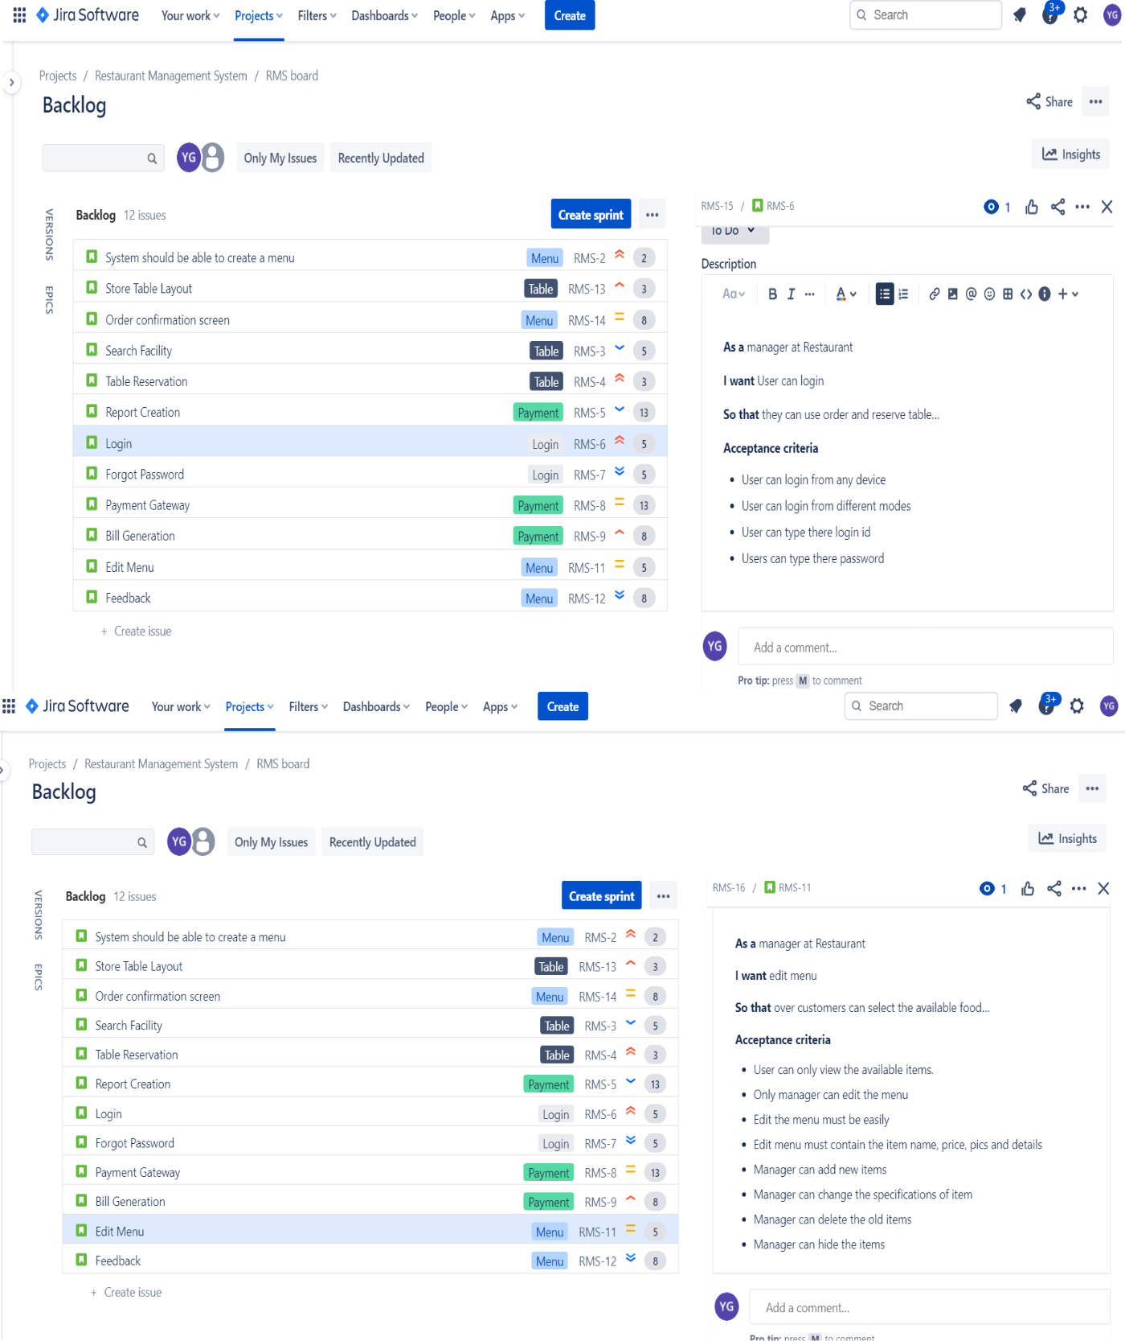

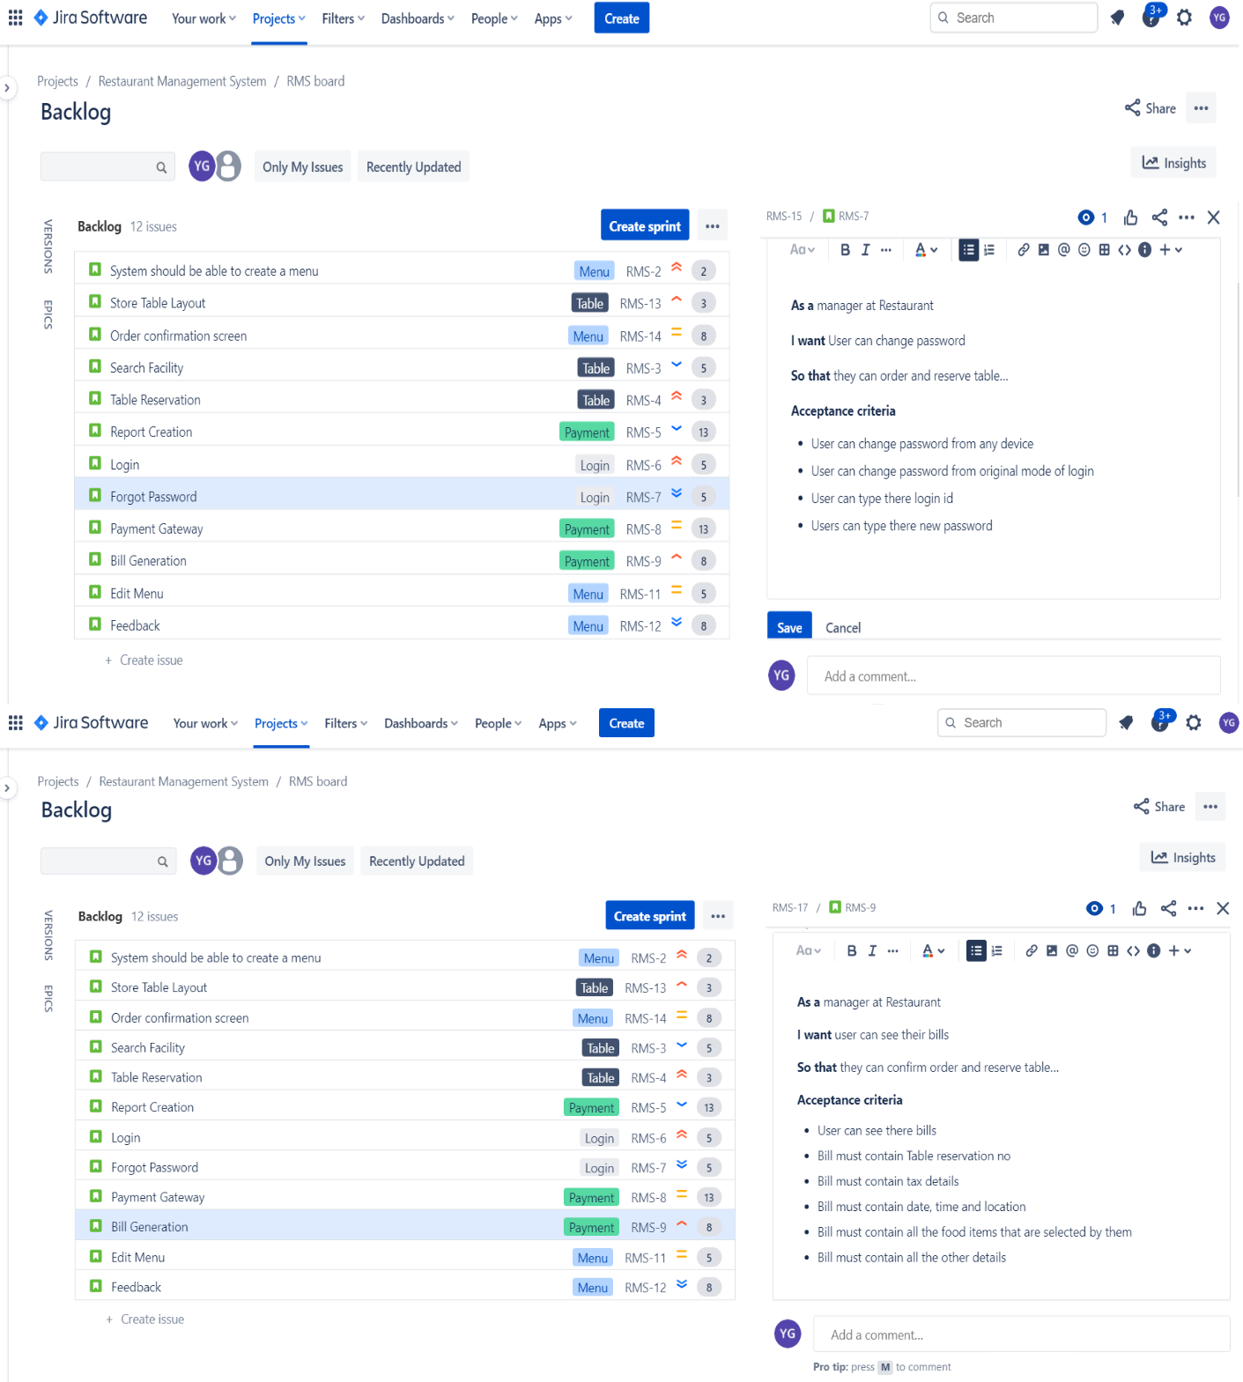

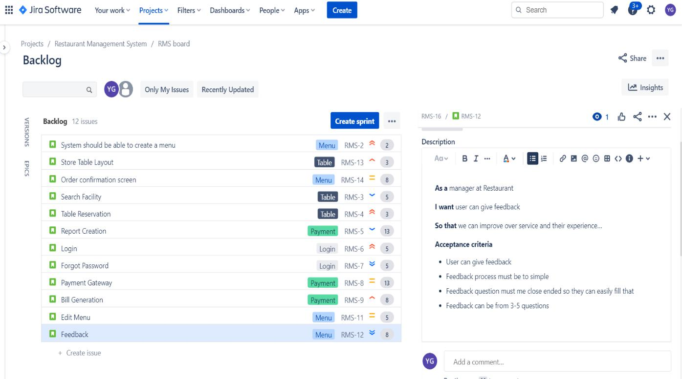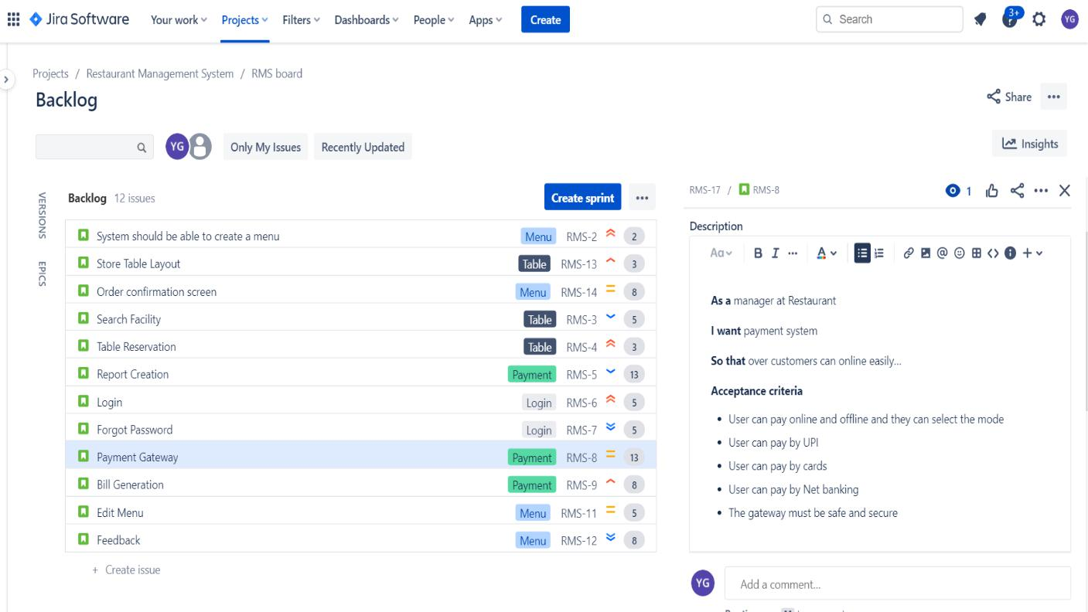

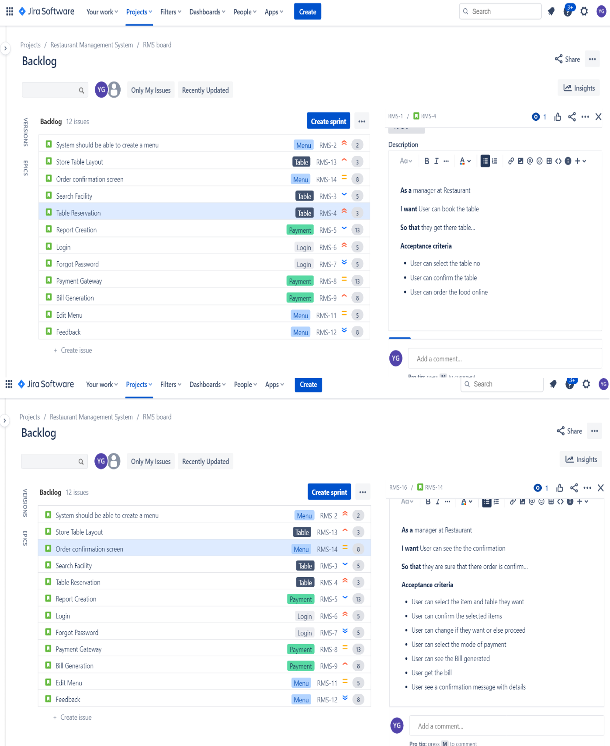

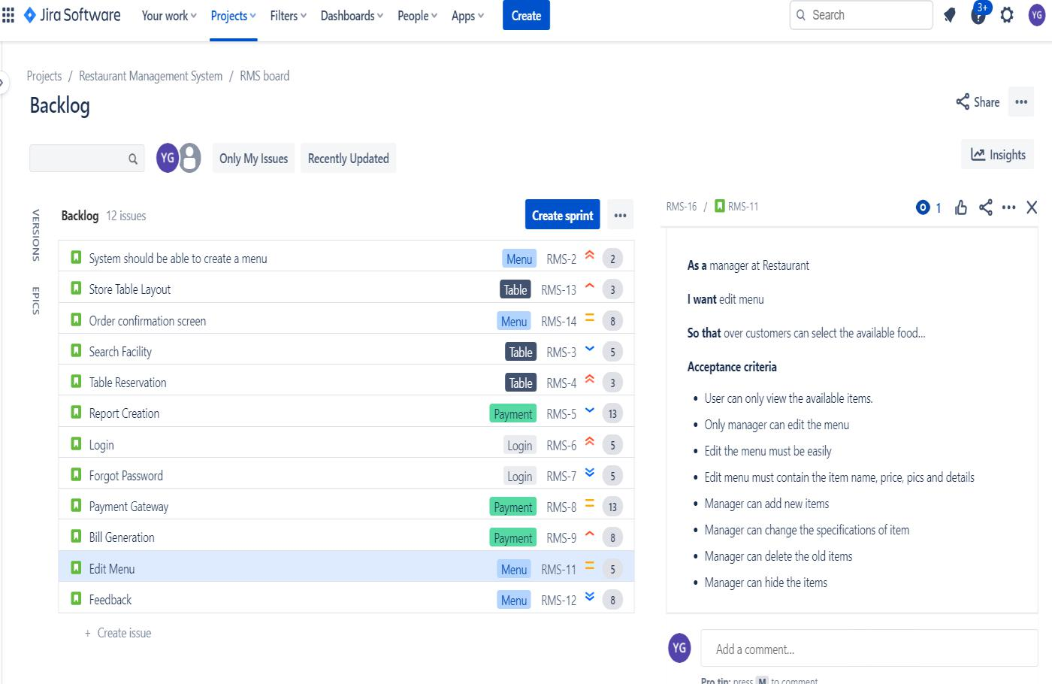

It’s time to add a sprint…

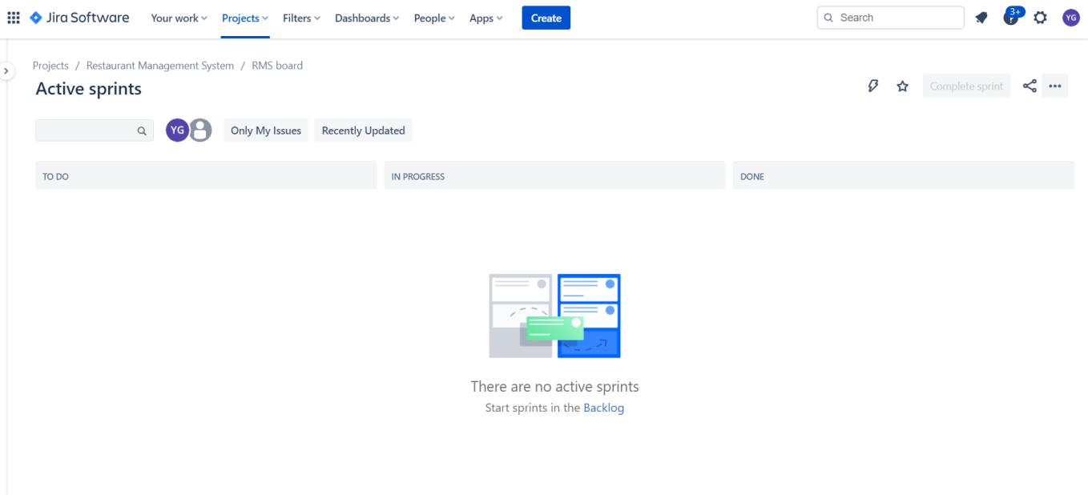

**Sprint Created:**

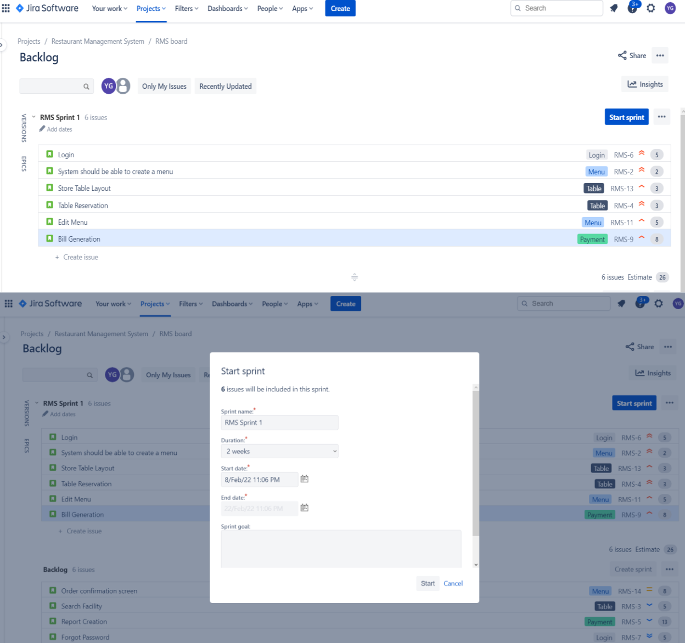

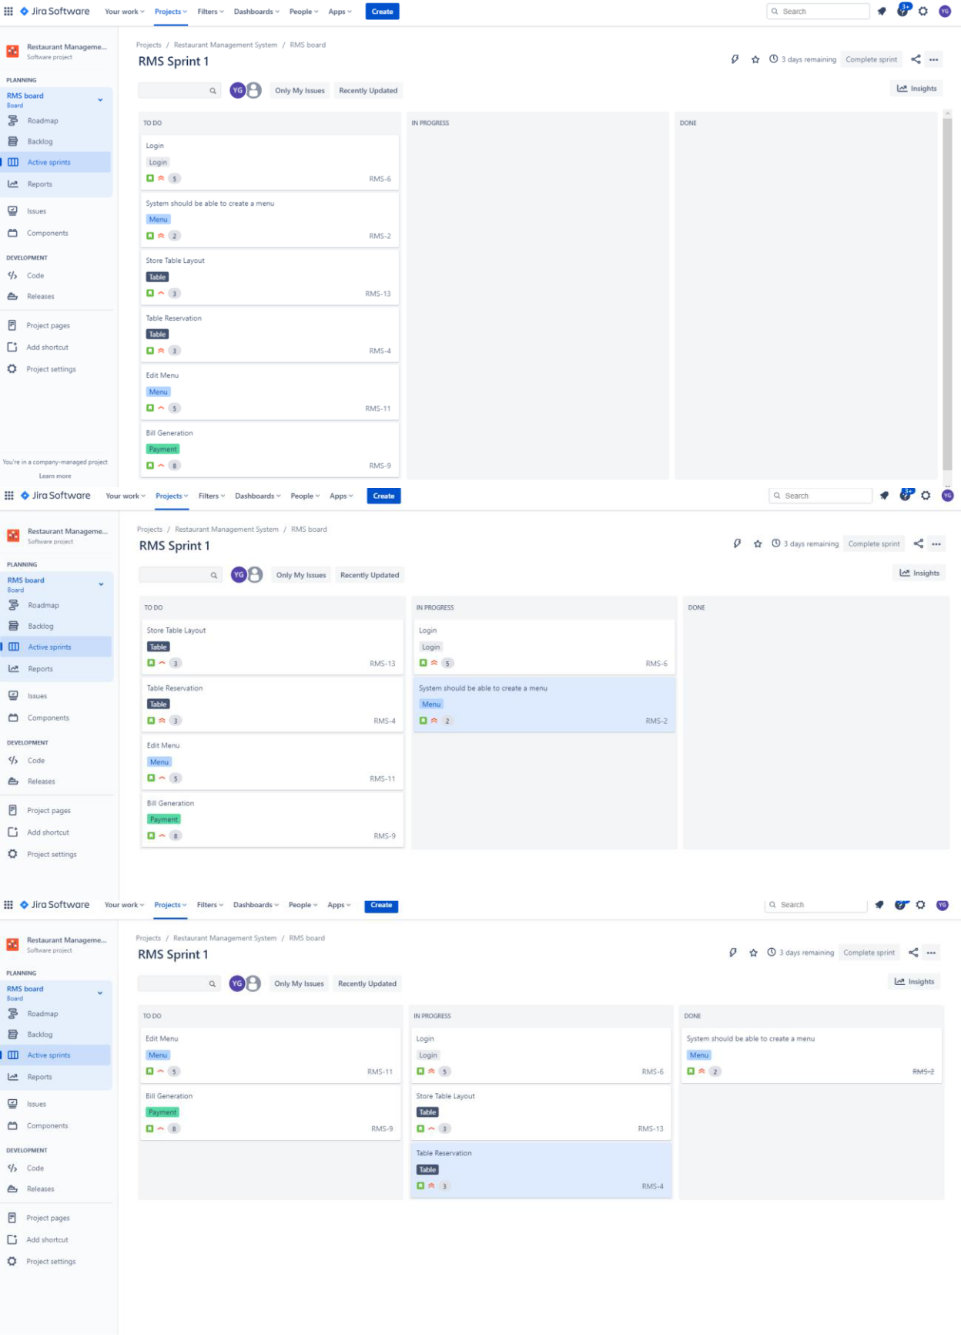

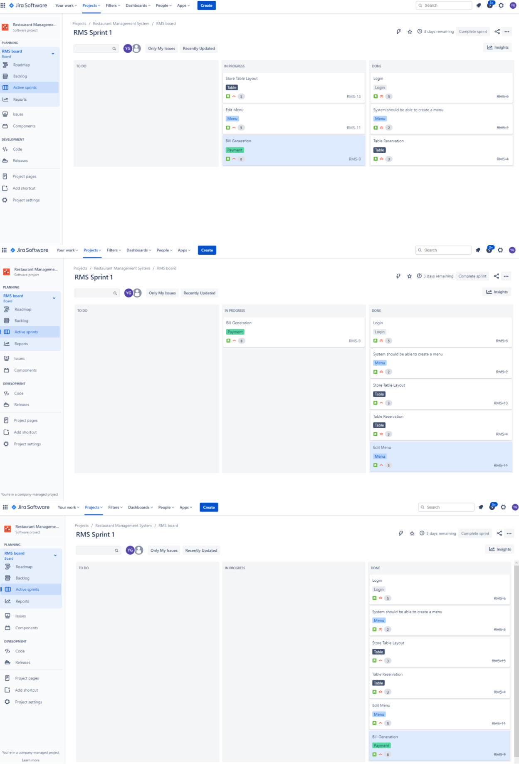

**Burnup chart :**

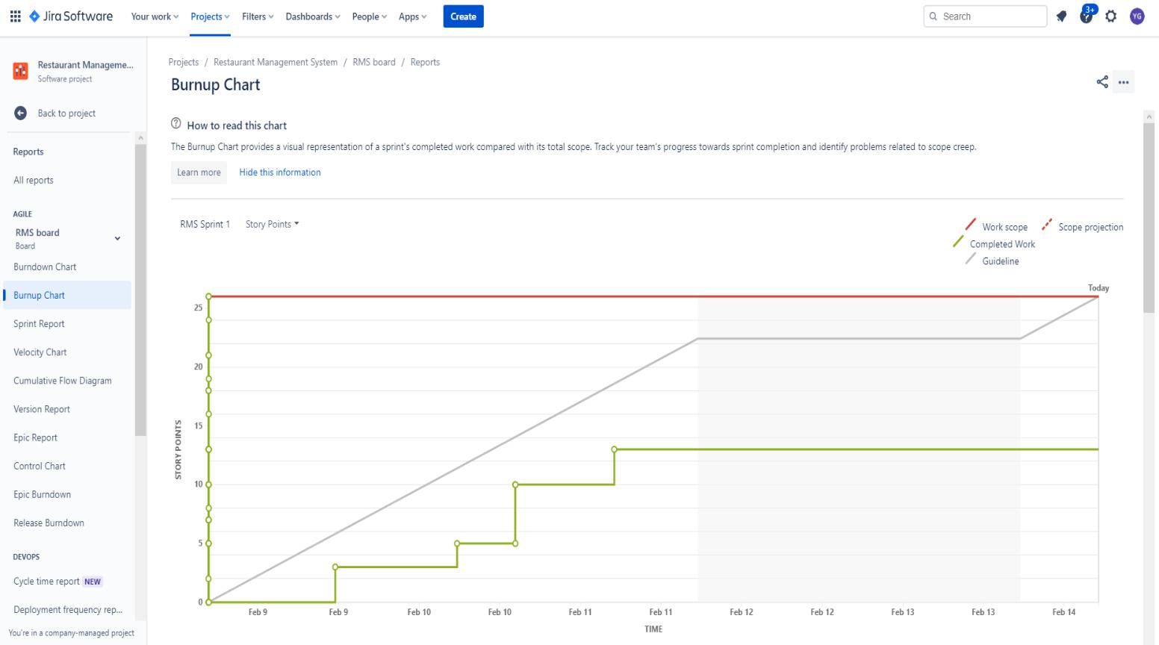

**Burndown Chart:**

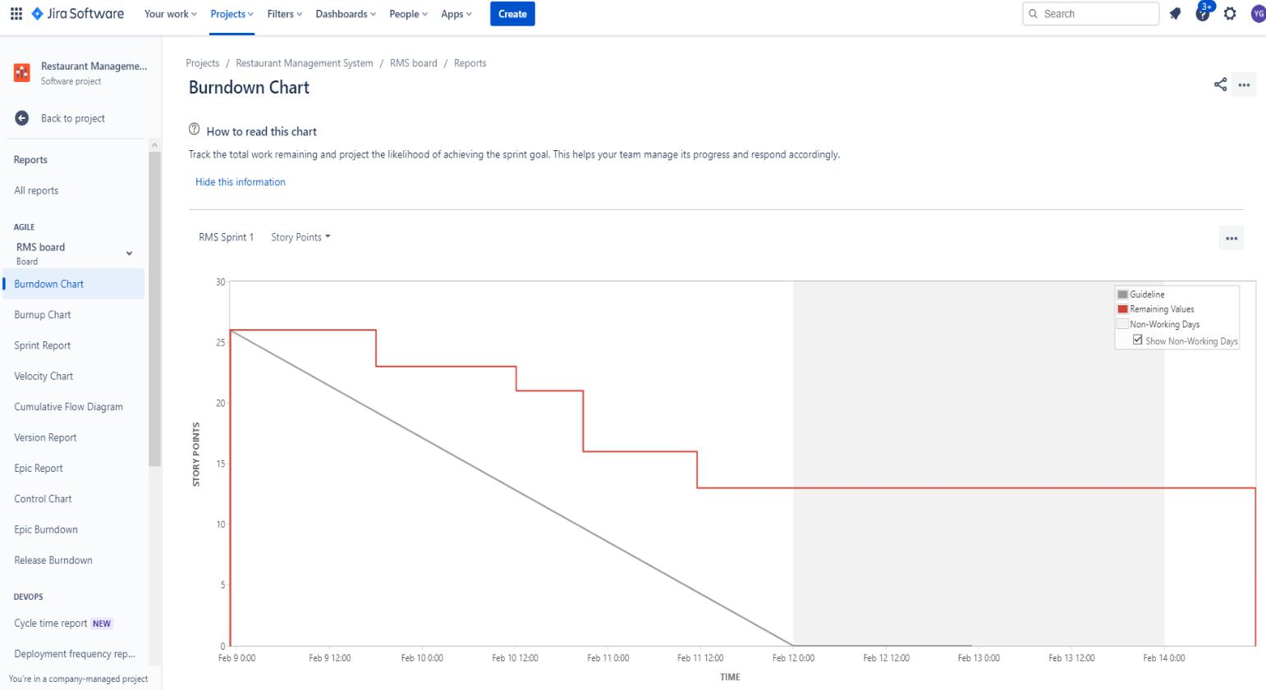

**Sprint Report:**

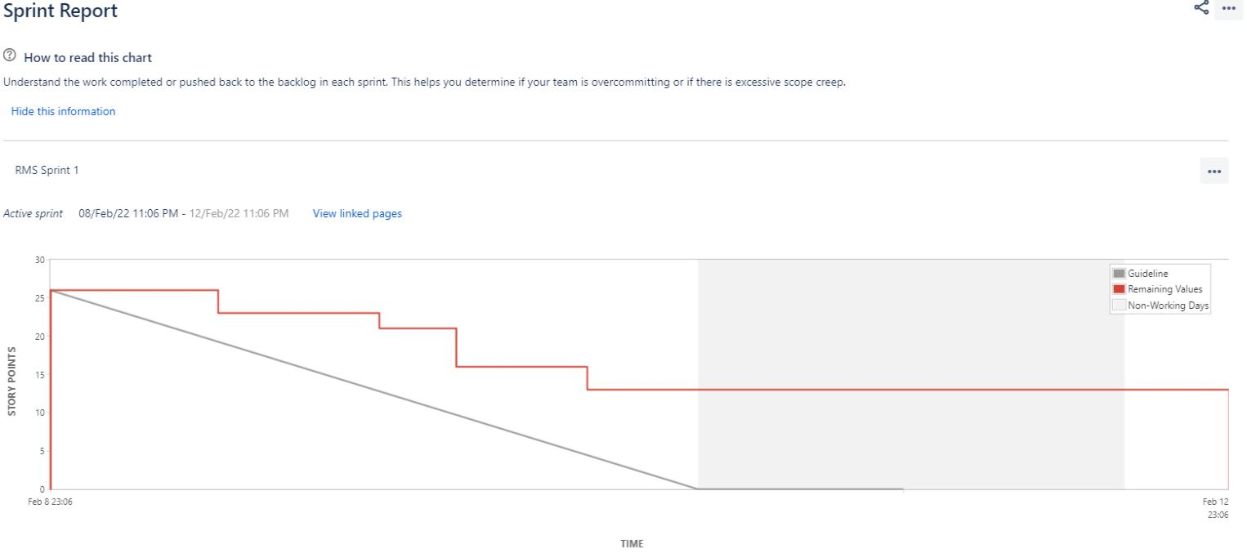

**Sprint Completed :**

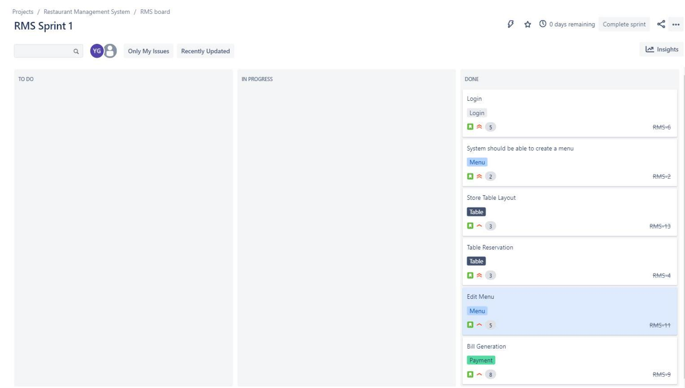

**Epic Report:**

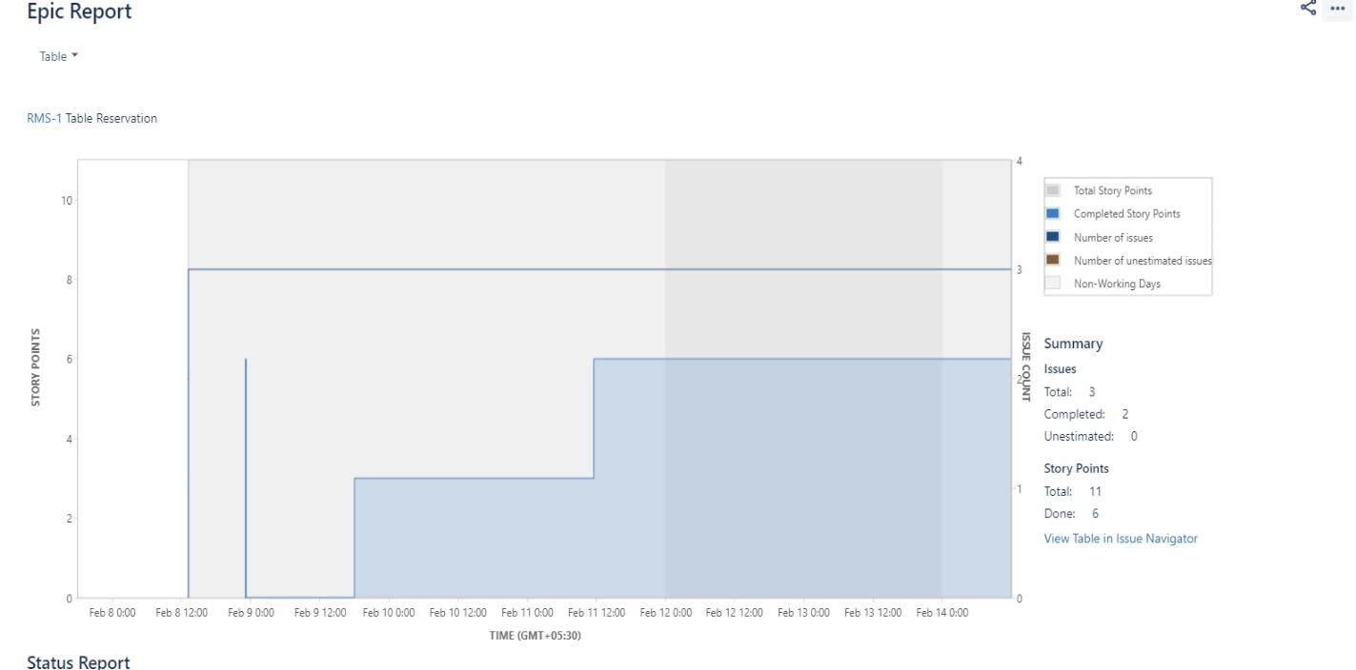

**Backlog Updated:**

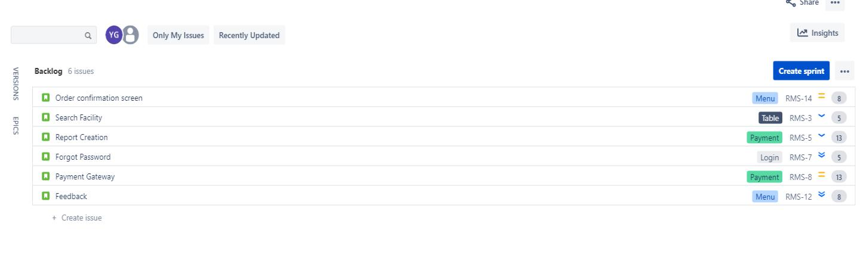



**Sales Dashboard:**

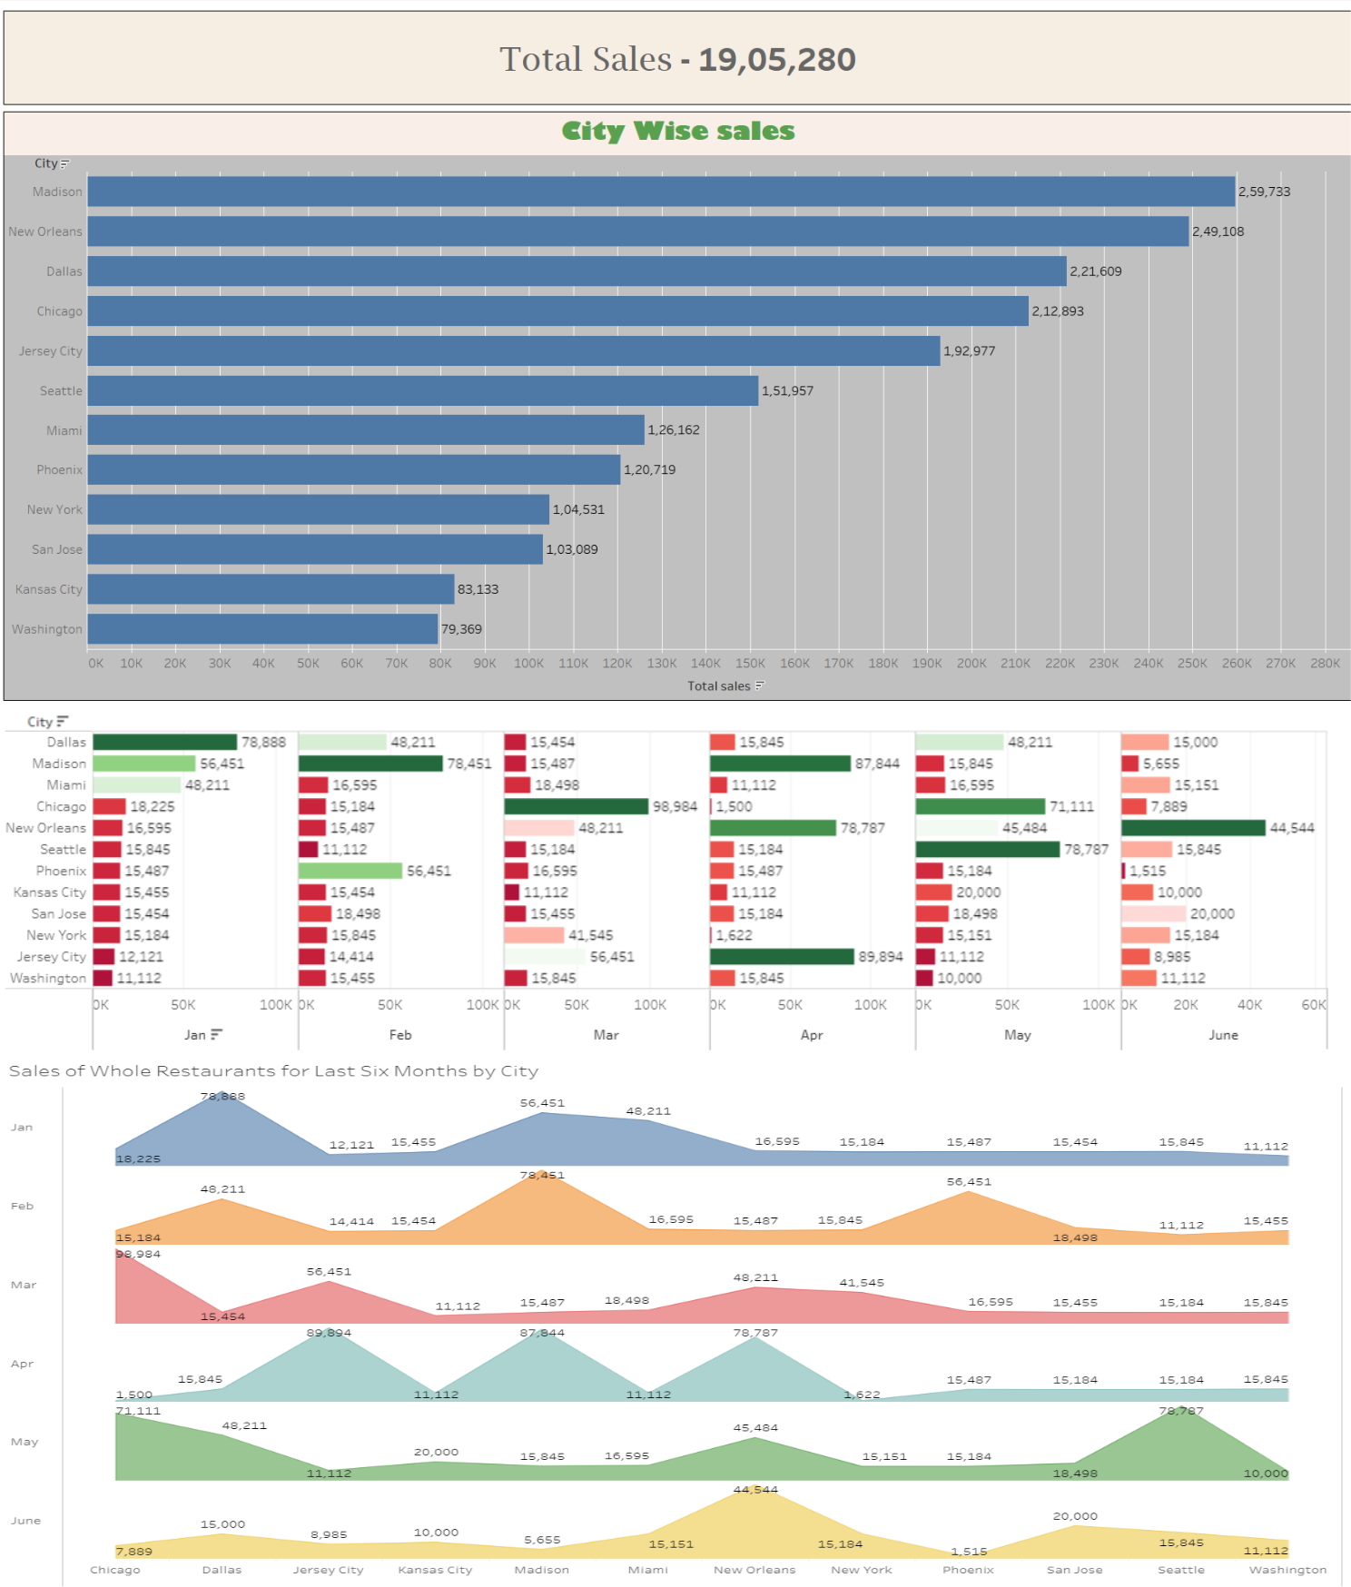

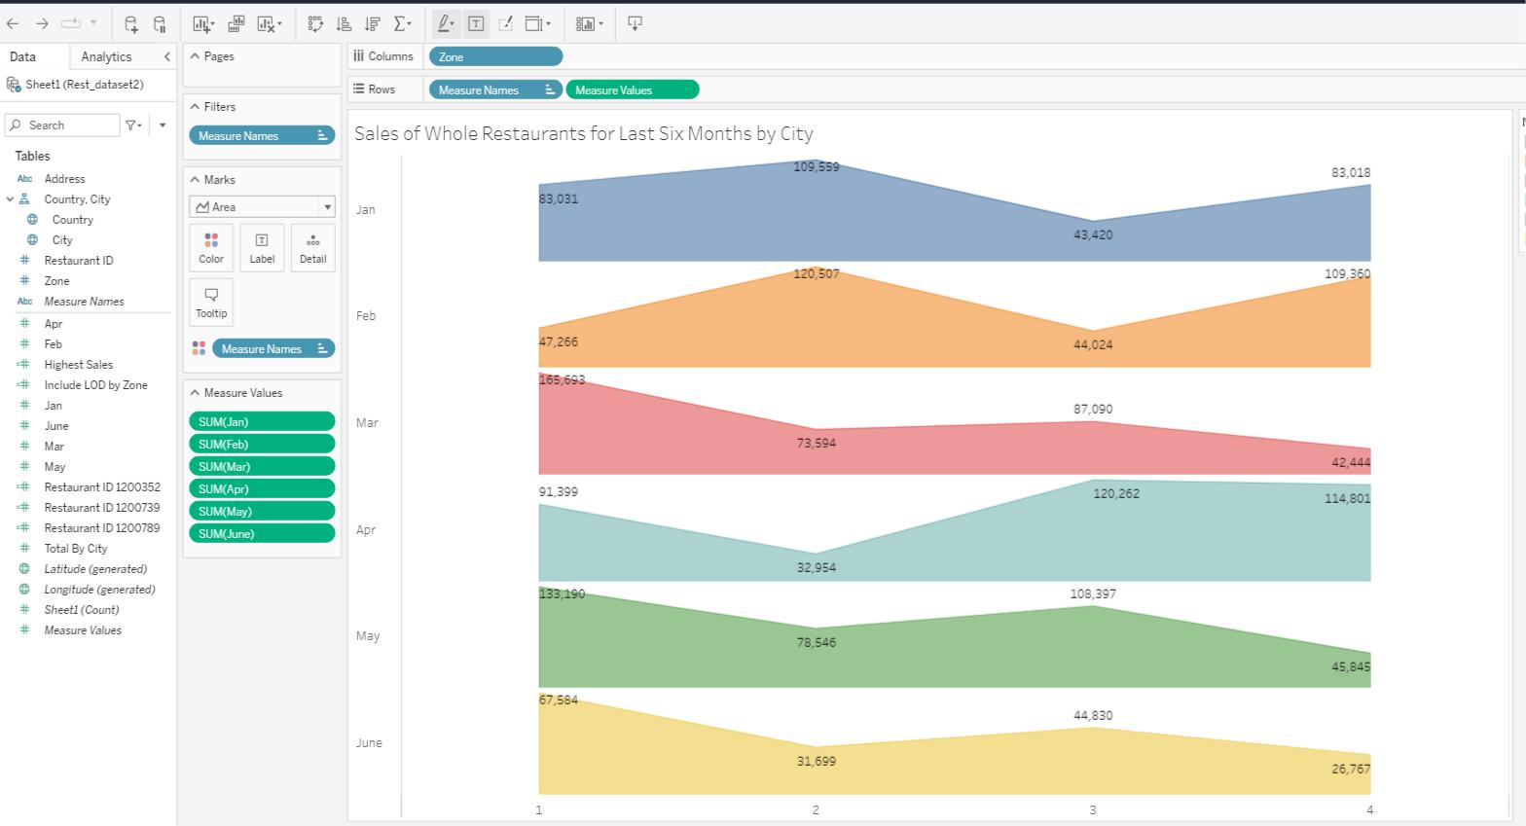

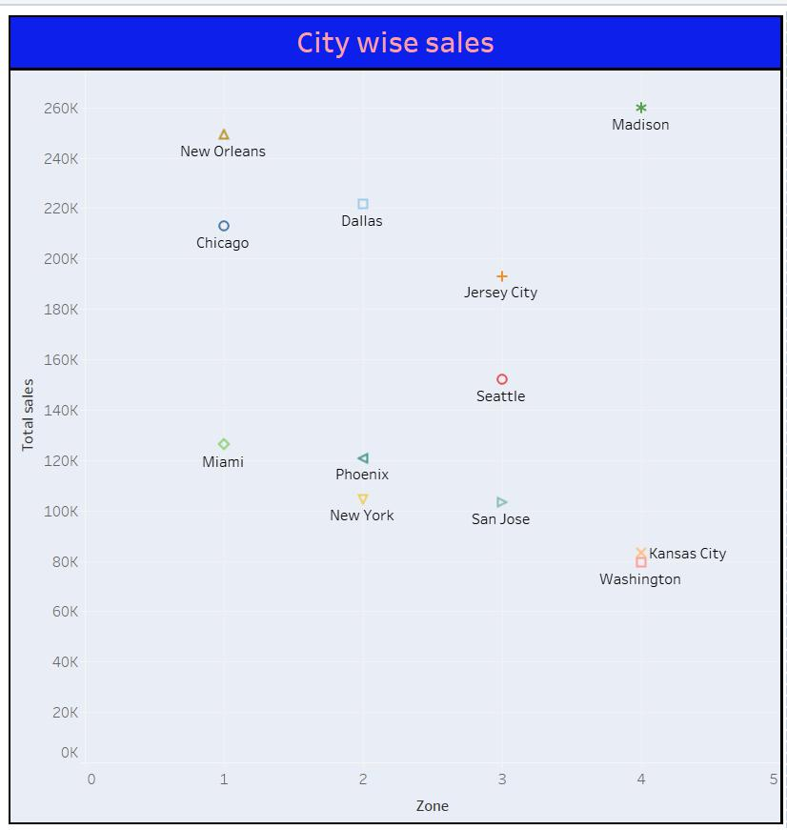

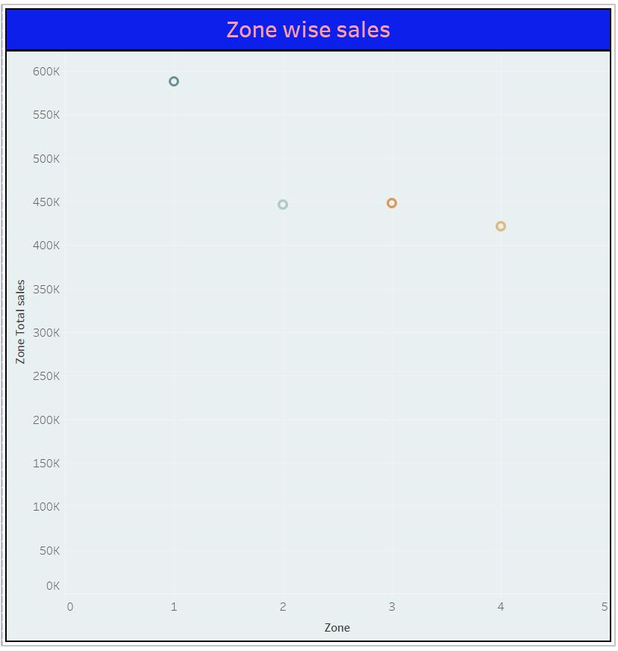

**Zone Sales Dashboard:**

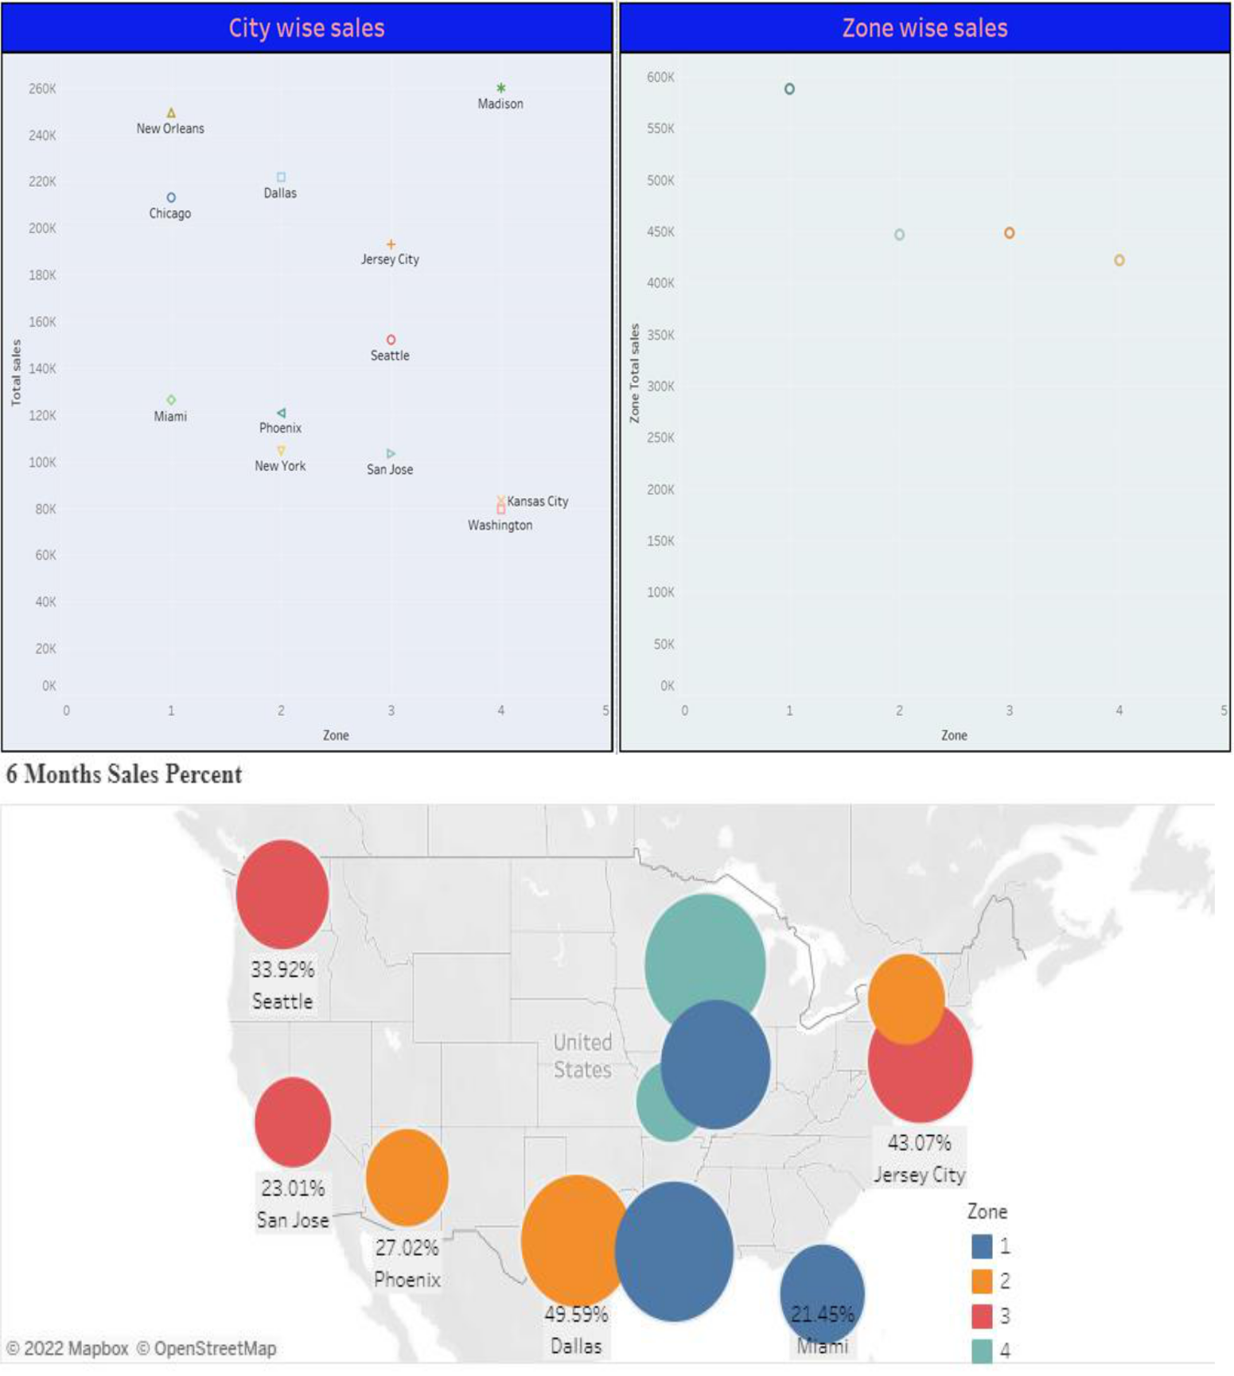

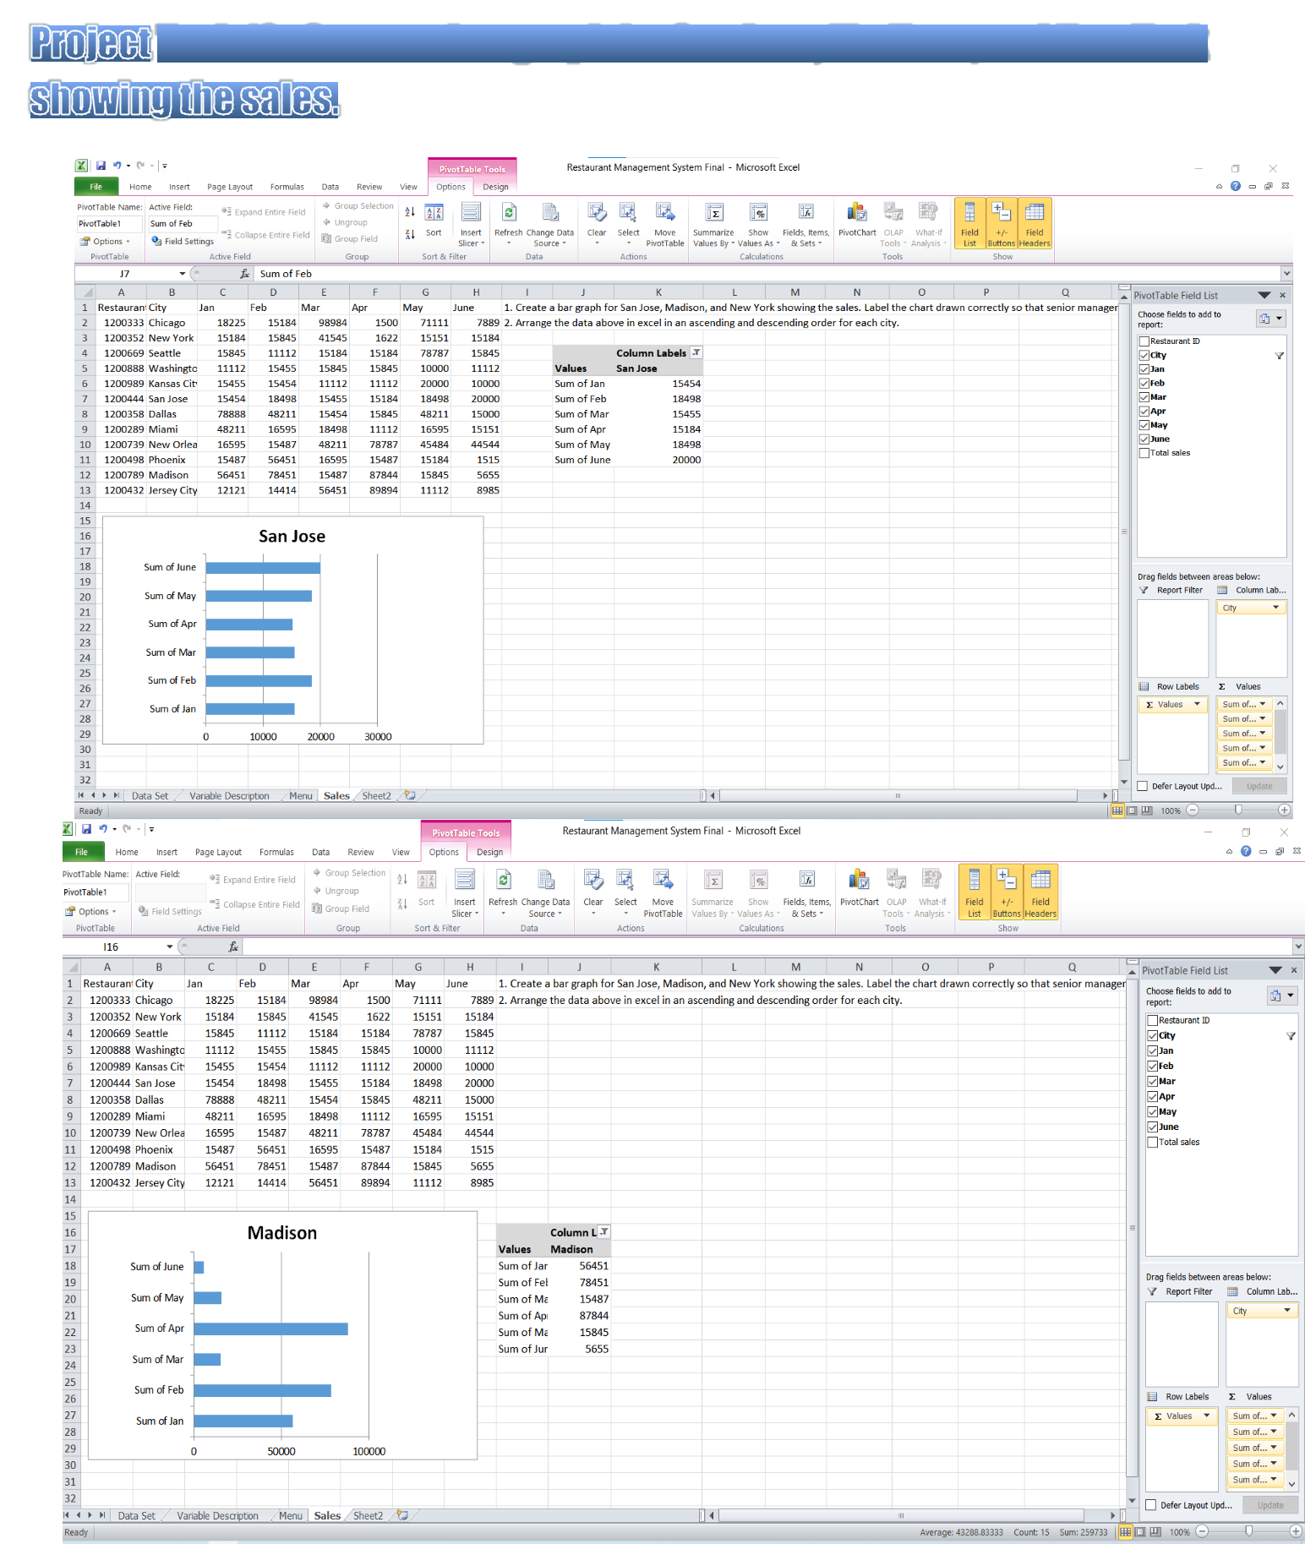

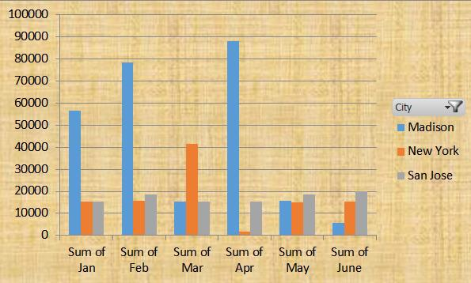



**Arranging the sales in ascending order city wise**

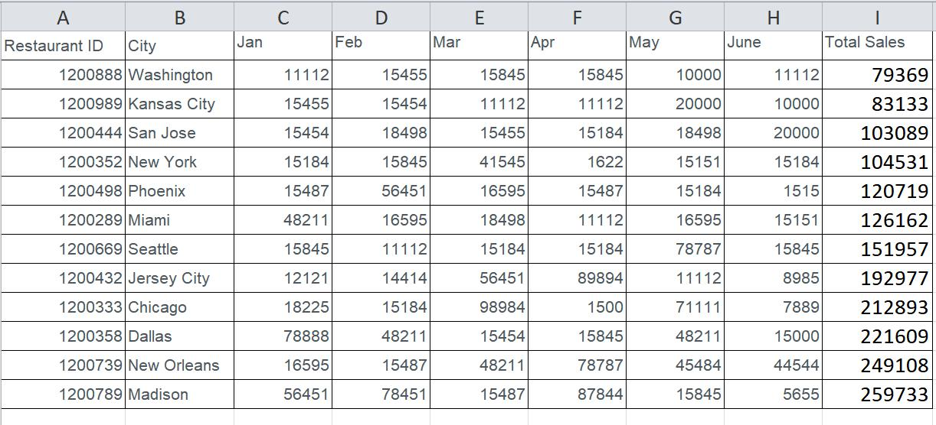

**Arranging the sales in descending order city wise**

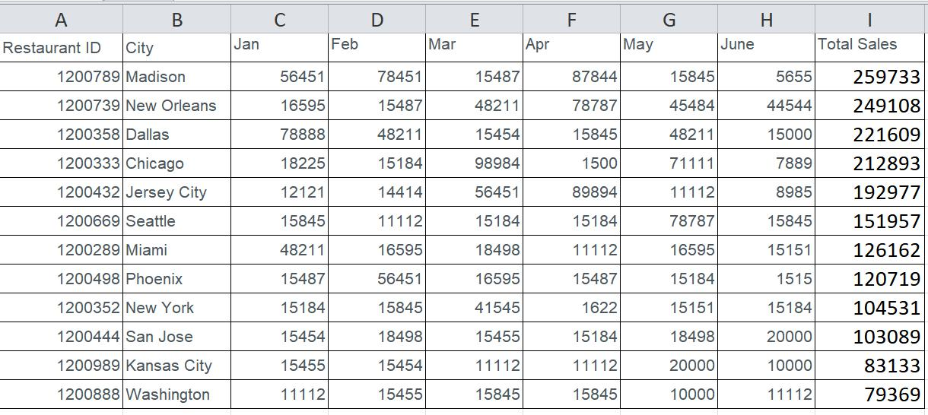



find the sales for the month of June

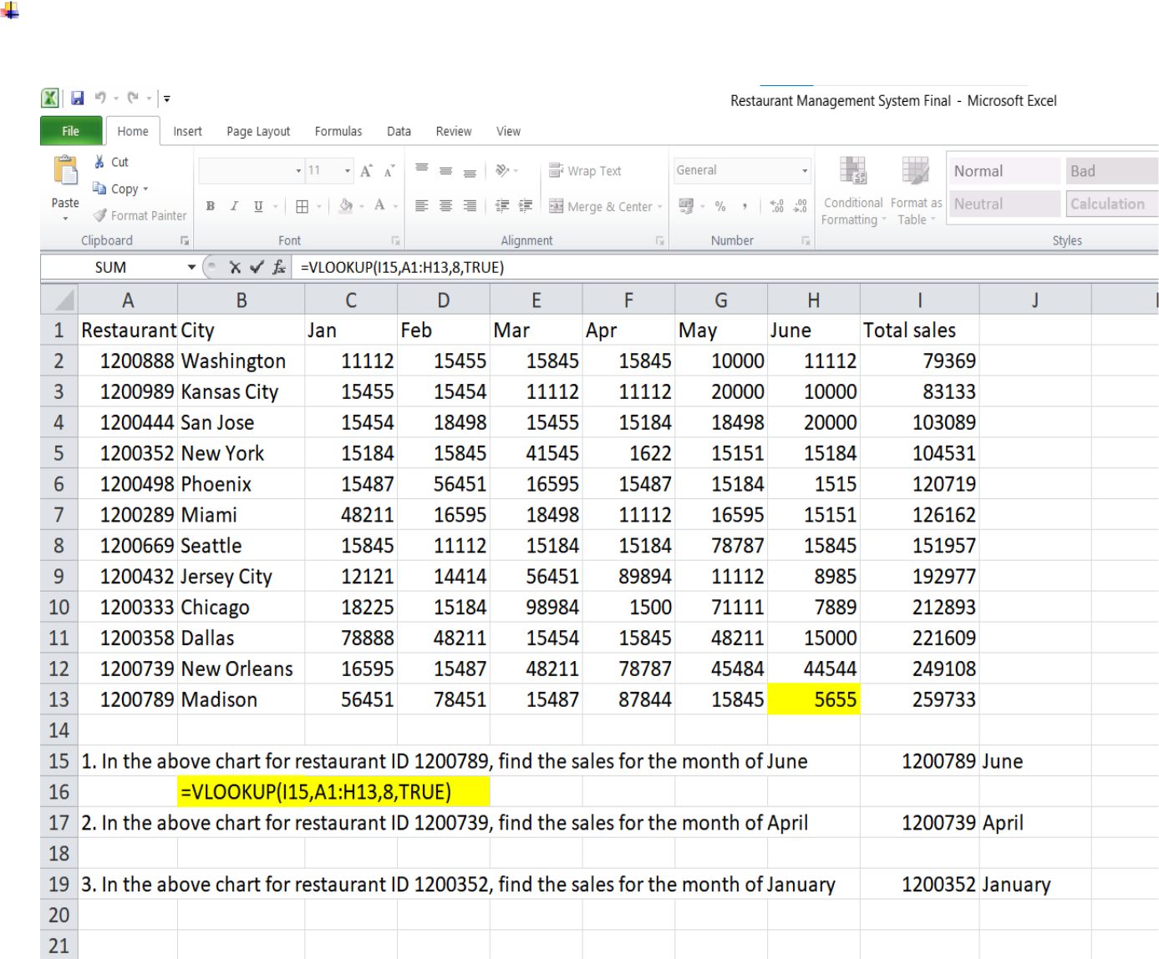

find the sales for the month of April

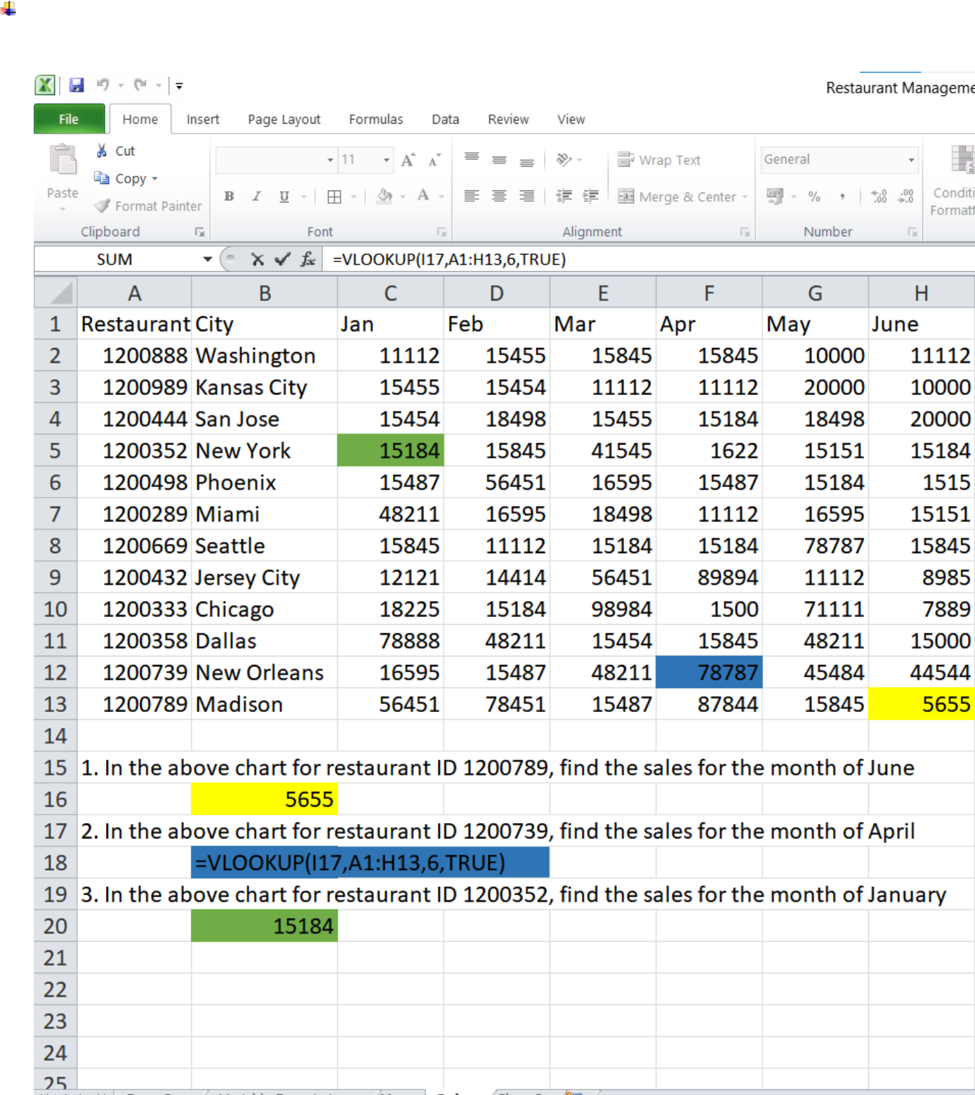

find the sales for the month of January

